

**CZ3005 Artificial Intelligence**

**Assignment 2**

Done by:

U1920095H Claudia Beth Ong

Tutorial Group: TS4

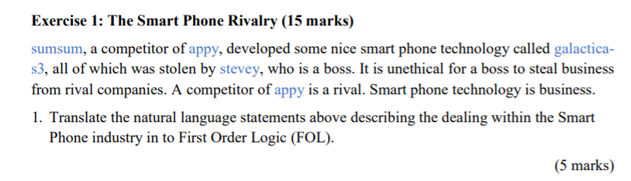

First Order Logic statements

|  |  |
| --- | --- |
| sumsum, a competitor of appy | 1. **company(sumsum)**   sumsum is a company   1. **company(appy)**   appy is a company   1. **competitors(sumsum, appy)**   sumsum and appy are competitors of each other |
| sumsum developed some nice smart phone technology called galactica-s3 | 1. **smartphonetech(galactica-s3)**   galactica-s3 is a smart phone technology   1. **develop(sumsum, galactica-s3)**   sumsum developed galactica-s3 |
| all of which were stolen by stevey | 1. **steal(stevey, galactica-s3)**   stevey stole galactica-s3 |
| stevey is a boss | 1. **boss(stevey, appy)**   stevey is a boss of appy |
| it is unethical for a boss to steal business from rival companies  a competitor of appy is a rival  Smart phone technology is business | 1. **∀ company(x), competitor(x, appy) → rival(x,appy)**   Every company x is a rival of appy if it is a competitor of appy   1. **∀ x, smartphonetech(x) → business(x)**   For every smart phone technology x, x is also a business   1. **∀ c, ∃ z, ∀ y, ∀ z, ∀ x,**   **company(c) ∧ company(z) ∧ boss(y, z) ∧ business(x) ∧ rival(c,z) ∧ steal(y, x) ∧ develop(c, x) ∧ business(x) → unethical(y)**  For every company c and for every boss y of company z, and for every business x,  there exists a company z such that if c and z are rivals and y steals x, and c develops x where x is a business, y is unethical. |
|
|



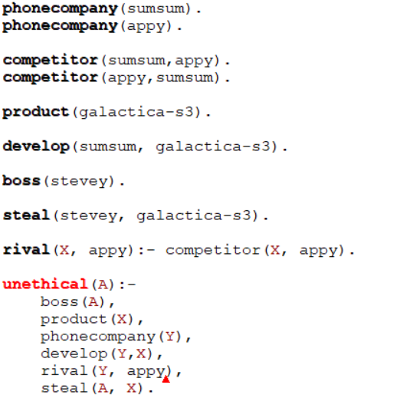



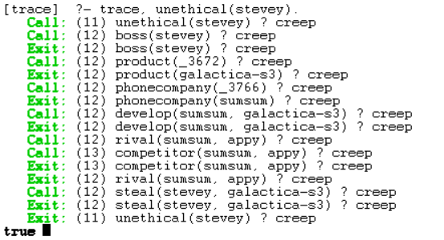

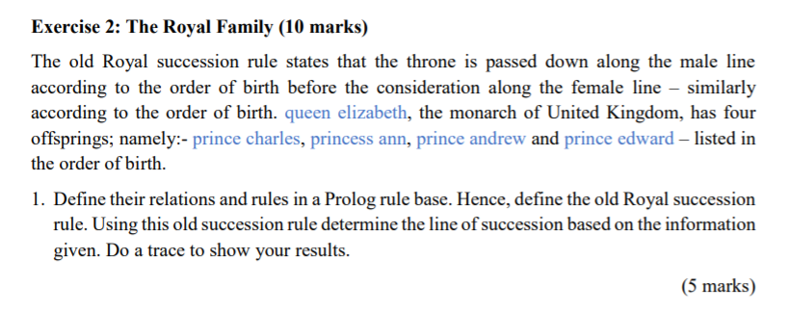

1. Does Prince Charles come before Princess Ann?

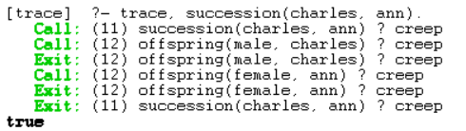

1. Does Prince Charles come before Prince Andrew?

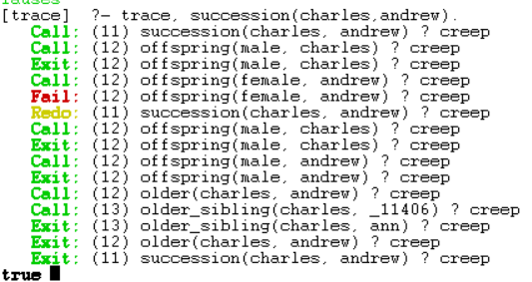

1. Does Prince Charles come before Prince Edward?

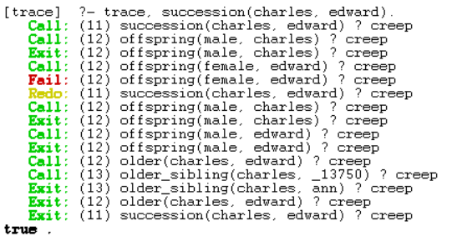

1. Does Princess Ann come before Prince Andrew?

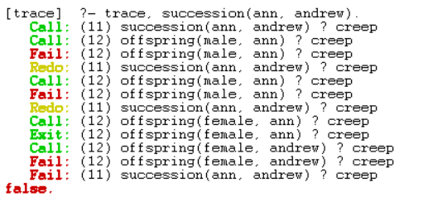

1. Does Princess Ann come before Prince Edward?

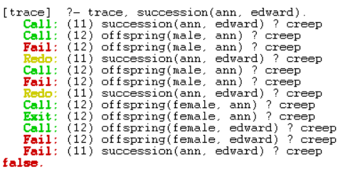

1. Does Prince Andrew come before Prince Edward?

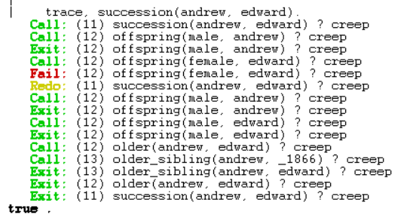

Therefore, the final succession line is:

**Prince Charles**

**Prince Andrew**

**Prince Edward**

**Princess Ann**

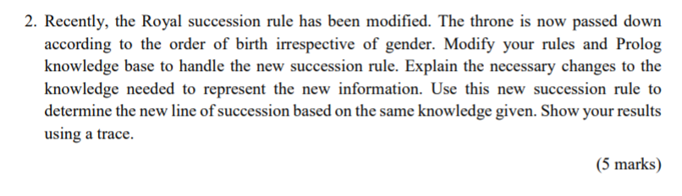

Since the line of succession is now irregardless of gender, the succession rule can be simplified from

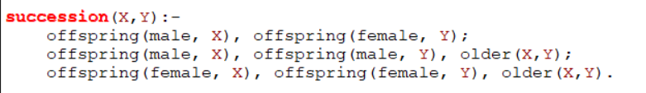

to



ie. as long as X is older than Y, X will precede Y in the line of succession.

1. Does Prince Charles come before Princess Ann?

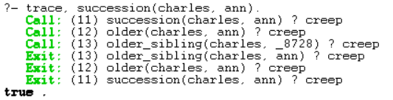

1. Does Prince Charles come before Prince Andrew?

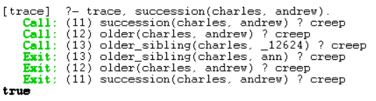

1. Does Prince Charles come before Prince Edward?

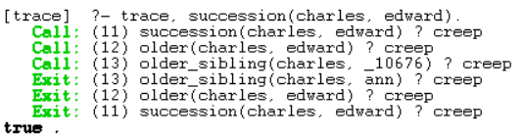

1. Does Princess Ann come before Prince Andrew?

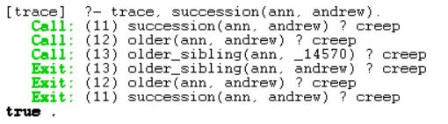

1. Does Princess Ann come before Prince Edward?

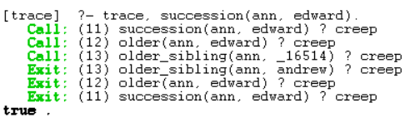

1. Does Prince Andrew come before Prince Edward?

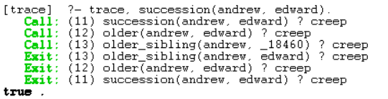

Therefore, the final succession line is:

**Prince Charles**

**Princess Ann**

**Prince Andrew**

**Prince Edward**